ANNUAL REPORT OF THE KHASI DEPARTMENT (2021-2022)

After the pandemic and national lockdown in 2020 due to covid-19, educational institutions across the state were closed down to contain the spread of the virus. In order to reached out students the teachers of the Department created whattsapp group for both even and odd semester students respectively to distribute notes and study material from time to time. Under the instruction of the HOD the classes were distributed among the teachers and taken through online mode by using various methods such as google meet, zoom etc. from April to October 2020. Thereafter, the Government re open the educational institutions for offline classes with strict protocol to be observed and adhered by all.
Offline classes for odd semesters commenced from 1st February 2021. Due to the pandemic the NAAC Peer Team visit to the college was delayed. Before the NAAC Peer Team visit the Department work hard to prepare the documents, internal marks, pass percentage, assignment of the students, attendance register and power point presentation. The Department along with the Principal, teaching staff, non-teaching staff and all the students work together wholeheartedly. Finally, the NAAC Peer Team visit happened on the 10th and 11th February 2021 and the college was accredited with ‘C’ grade.
Offline classes continued till 7th March 2021. During the offline classes teachers revised the course and discussed the pass question papers in order to help the students prepare well for the odd semester examination which commence from 15th March till 4th April 2021 in both offline and online mode. After the exams answer scripts were distributed among the teachers of the Department under the instruction of the HOD. Offline classes for the even semesters started on the 5th April 2021. Before the classes started the HOD called for a Departmental meeting in order to distribute the syllabus, assignments, internal test and allot classes among all the teachers. From May to June 2021 due to the rise in the number of covid-19, offline classes were suspended and from 20th July to 4th August 2021 even Semester examination was held in both online and offline mode.
From 1st September 2021 the offline classes started with the odd semester system. The Department held a Departmental meeting to distribute the syllabus, allot number of classes and conducted tests for both even and odd semester at the end of each semester. The internal marks of each semester were finalised by the HOD and the marks were submitted to the convener of examination committee. ICT classes were taken by all the teachers of the Department to enrich the learning process for the students.
In spite of all the hurdles, the Department managed to carry on and ensure the smooth functioning of both online and offline classes, activities and internal assessment for students. The pandemic has taught us how to deal with such challenging situation and come up with other alternative means to adapt the changing circumstances by making the best use of technology available to us.
ICT classes taken during the academic session 2021-2022
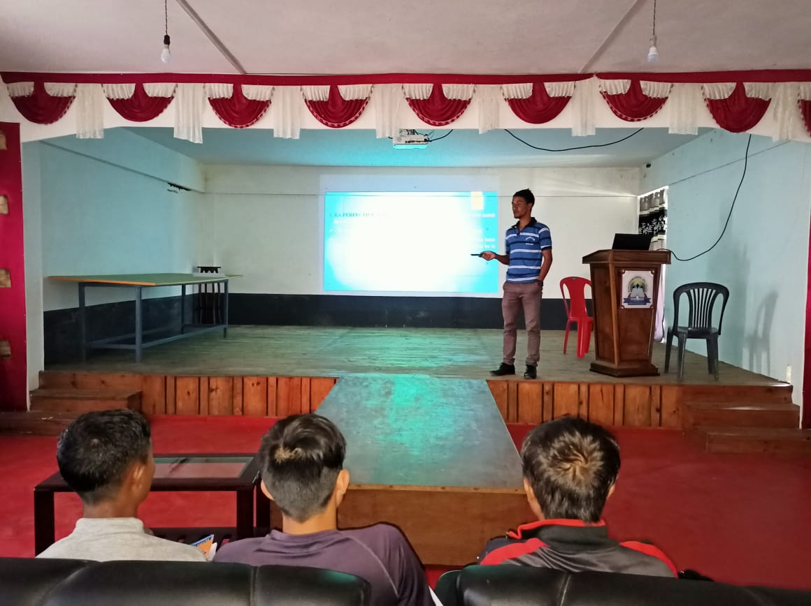 | 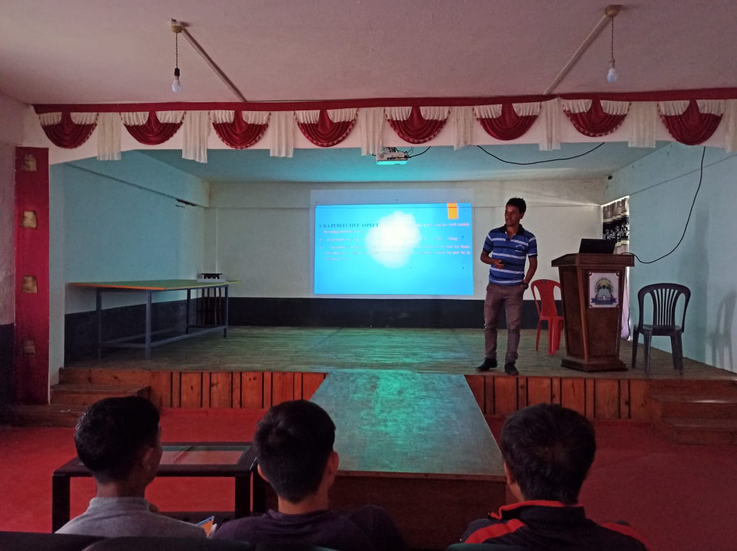
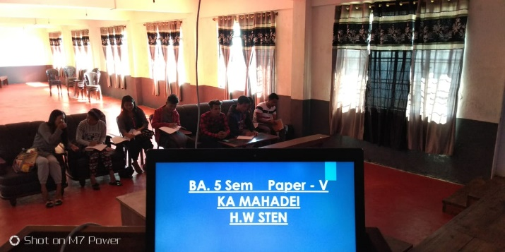 | 